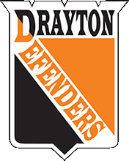
Drayton Minor Hockey Association
COACHES APPLICATION
2023/2024 Season

Name: Primary Phone:
Address:
Email:
Team Selection: (Please Select only 1 option of Rep or Local League plus age group)
Level: Rep ☐ Local League ☐
Age Group: U9 ☐ U11 ☐ U13 ☐ U15 ☐ U18 ☐

Please select your valid level of National Coaching Certification Program (NCCP):
i) Coach 1 ☐ Coach 2 ☐ Development 1 Trained ☐ Development 1 Certified ☐
Other:
ii) Hockey University- Planning Safe Return ☐ Gender Identity ☐Respect in Sport ☐

Past Coaching Experience
Year | Team | Division | Position
Tell us about your coaching philosophy:

Drayton Minor Hockey requires that you apply each year. The Head Coach will be responsible for picking their team staff. All members of the team officials are required to be up-to-date on certications based on role. Annual police check is required for all team officials and on-ice helpers. All applications are subject to approval by the executive as stated in the bylaws. All applications will receive notice of receipt, followed by update of selected successful candidate.
**Email completed form by July 1, 2023 to
Jenny Bults bultsjb@gmail.com**

