Obtaining a Vulnerable Sector Check:

Before you start, download and fill out the Vulnerable Sector Check letter from the “Coaches” menu on the DMH website. You will be asked to upload a copy of this as part of your VSC application.

To apply:

* Go to [**www.opp.ca/recordchecks**](http://www.opp.ca/recordchecks)
* Scroll to the bottom of the page and select:



* Answer the questions
* 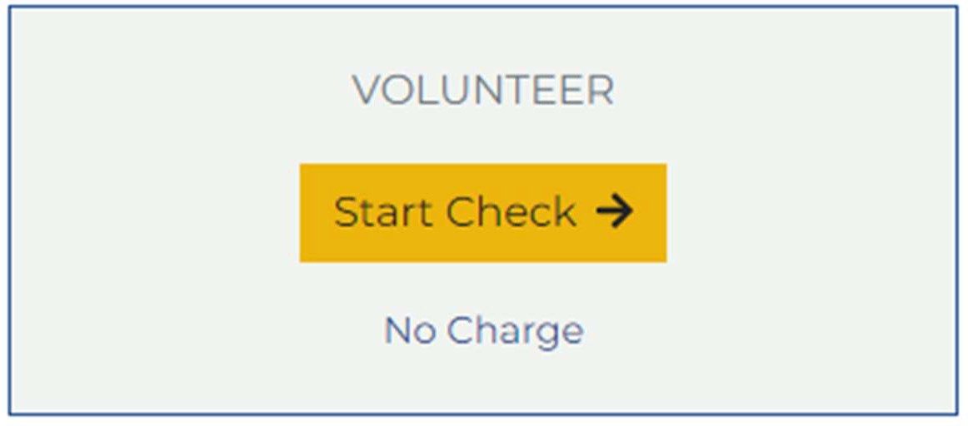Once you have answered the questions, the following prompt will appear towards the bottom of the screen, ensure you are selecting to start a **Vulnerable Sector Check,** NOT a Criminal Records Check.
  + Complete the required information and submit. Note the approximate timeline for returning the VSC to you.

**Once you have your returned VSC, you can now follow the steps to submit it directly to the OHF through their screening portal** [**here**](https://forms.office.com/pages/responsepage.aspx?id=s88_mthsgUGOi8KxPBphVRNFN0_ZyflGmReI6w2hk6NUOUowVjgyRVI5R0hMUjUzMUVLMU5WTVc2OS4u&route=shorturl)**.**